Data Visualization Concepts

Inhalt

1. Introduction 2

1.1 Types of Visualizations 2

1.2 History of visualization 2

1.2.1 Varying Data 2

1.2.2 Geographical Visualization 3

1.2.3 Bio-Medical Visualizations 4

1.2.4 Economy 5

1.2.5 Space-Time-Series Visualization 5

1.2.6 Space-Time-Map Visualization 6

1.2.7 Network Visualization 6

2. Fundamental Data Processing 7

2.1 Data types 7

2.1.1 Classification 7

2.1.2 Common Data Set Structures 7

# 1. Introduction

* Why visualization?
  + Powerful alternative to textual information
  + Exploits human capabilities to recognize patterns
  + Effective way to communicate idea

## 1.1 Types of Visualizations

|  |  |  |
| --- | --- | --- |
| **Type** | **Advantages** | **Disadvantages** |
| Numbers, Text | Precise | Un-interprative |
| Charts | Reveals temporal relations and trends | Imprecise |
| Maps | Abstractions make sure that important aspects can be easily seen  Maintains spatial distance relations | Can be overloading and distracting |
| Graphs | Shows connections properly | Not quantitative distances or times |
| Network systems | Can represent complex relations |  |

## 1.2 History of visualization

### 1.2.1 Varying Data

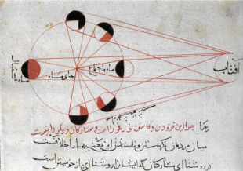

Produced by Biruni ca. 1030, shows phases of the moon

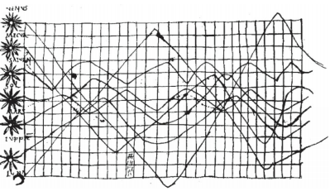

Ca. 1000, shows planetary motion

### 1.2.2 Geographical Visualization

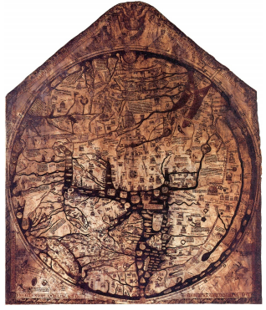

Famous Hereford map, largest surviving map of the Middle Ages (1280s)

Depicts land masses of Asia, Africa and Europe with Jerusalem at the center

### 1.2.3 Bio-Medical Visualizations

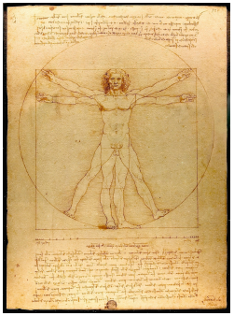

Vitruvian human proportions by Vitrivius, illustrated by Leonardo Da Vinci (1490)

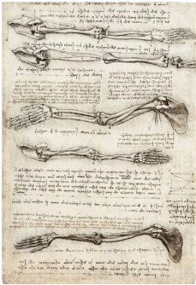

Leonardo Da Vinci’s study of the motion of the human arm (1510)

### 1.2.4 Economy

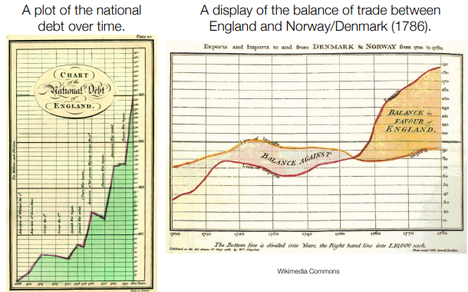

William Playfair’s examples of using abstract chart axes for other parameters

### 1.2.5 Space-Time-Series Visualization

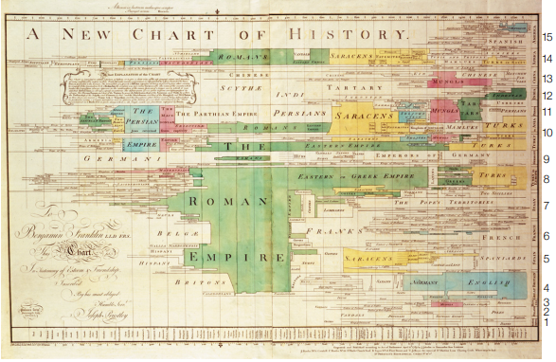

Joseph Priestley’s New Chart of History (1769)

### 1.2.6 Space-Time-Map Visualization

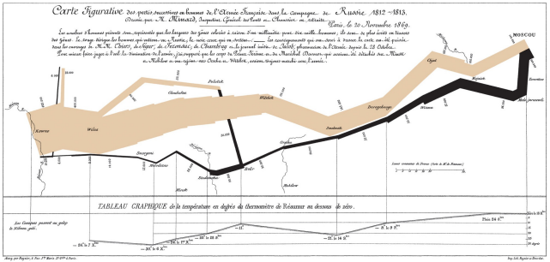

Minard’s map from 1869, showing Napoleon’s march on Moscow, Color indicates the direction of movement, The width of the line conveys the size of the army at that location

### 1.2.7 Network Visualization

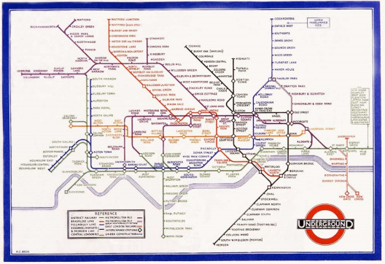

London underground map design conceived by Harry Beck (1931)

# 2. Fundamental Data Processing

## 2.1 Data types

### 2.1.1 Classification

* Nominal
  + Just different states without classification
* Ordinal
  + Order, although not consistent distances
* Numerical
  + Clear numerical numbers

### 2.1.2 Common Data Set Structures